These are for the SNES. Leave a bar at the bottom so that we can write 2-3 lines of text. Here’s a refresher on [SNES specifications](https://megacatstudios.com/blogs/press/super-nintendo-graphic-guide).

Rather than just static screens, we can make these animated. Basically they would be special backgrounds and sprites that make a little movie.

**I. Sir Clay le Pool - Frog**

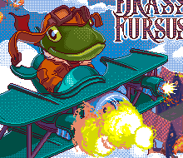

**Intro Scene**

Clay’s ship flying left to right do loops and other stunts. This video is not in the right perspective but it might offers some [inspiration](https://youtu.be/uaM9aryUGUs?t=16s).

The background can just be a sky with clouds and speed lines

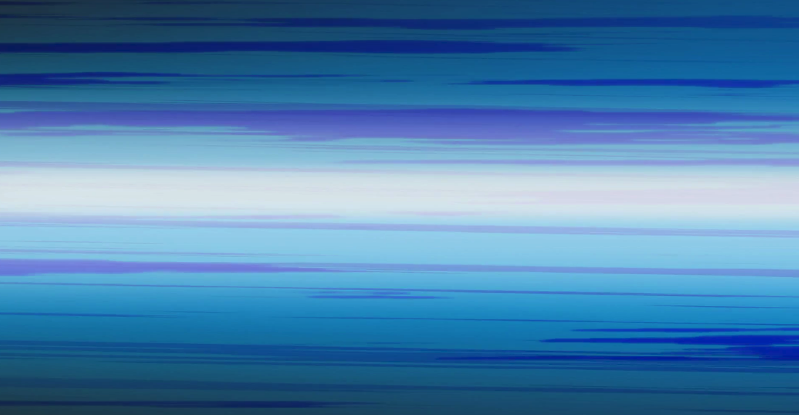

**Victory Scene**

Close up of Clay, with his mouth hanging open. There is a floating, shining crystal that is the light source for the scene. Crytsal in the foreground. Would be great to do the glowing as an animation.

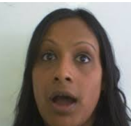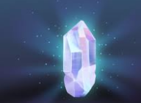

**II. Flamingo**

**Intro Scene**

Let’s reuse the zeppelin assets you made for his charge attack



We can have a bunch of these flying left to right through some clouds. The text will talk about his luxury airship cruise business.

**Victory Scene**

Let’s reuse the Flamingo head for the charge shot too. Have it be part of his body. He will be in the foreground, rubbing his wings together as if they were hands. In the background there will be a museum entrance at night with crowds and lines of people outside

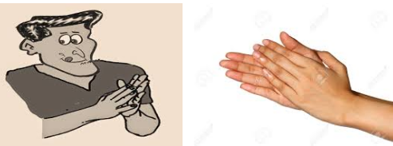

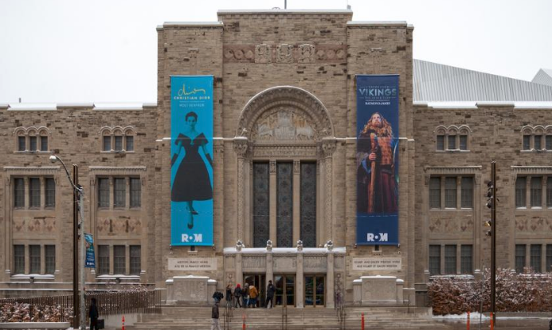

**III. Mako and Harp**

**Intro Scene**

It should show Mako with Harp in her mouth, and in Harp’s mouth there is a rope leading to a tied up rat criminal (Make and Harp are bounty hunters after all). Mako is also grabbing the rope with one of her fins.

**Victory Scene**

Mako and Harp on a tropical beach building a sandcastle. Mako is waving at the camera/audience with one fin, in her other fin she is holding a small shovel. Harp is wearing sunglasses and has a shovel in his mouth.

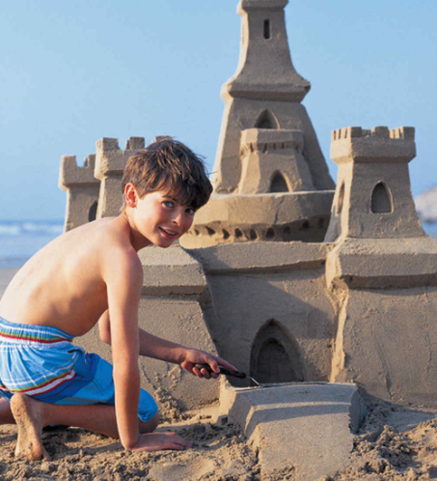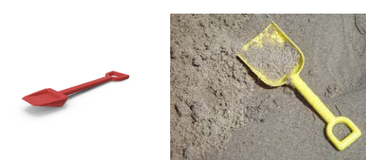

**IV. Yawny the Lion**

**Intro Scene**

Shows Yawny in bed, sitting up and reaching for his alarm clock, which is going off, shaking. Making it steampunky, with extra gears and nonsense. Yawny is wearing pajamas.

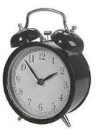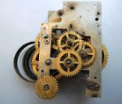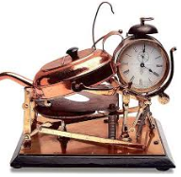

**Victory Scene**

Yawny is smirking and breaking the crystal in half



**V. Ratatosk the Squirrel**

**Intro Scene**

Ratatosk peering around the corner of a wall (in the foreground), in the background there is a strange ritual with glowing alchemical symbols

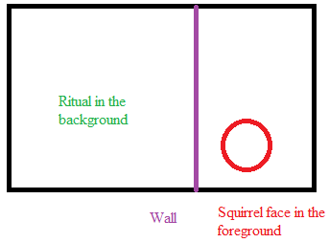

**Victory Scene**

Ratatosk laughing maniacally, with his hands in the air. The crystal is in his chest, glowing. Below him is the city, small.

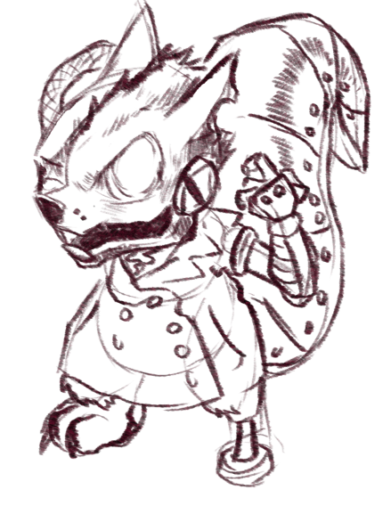

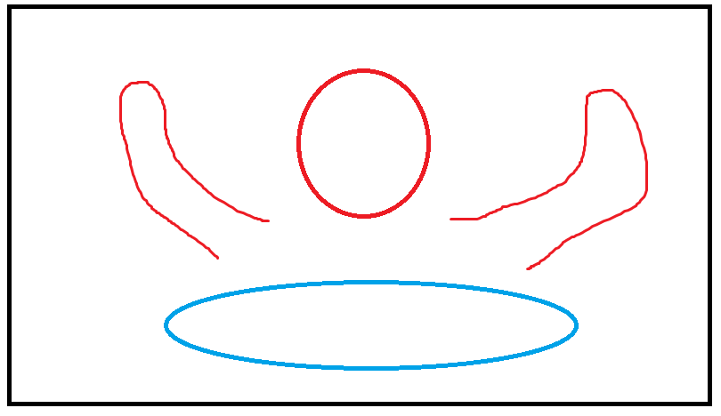

Red is the squirrel with his hands in the air. Blue is the city beneath him, in miniature. It should look like an [old Victorian city](https://www.google.com/search?rlz=1C1GGRV_enUS788US788&biw=1920&bih=925&tbm=isch&sa=1&ei=ghh4W634FIiE5wL0047IBA&q=victorian+city&oq=victorian+city&gs_l=img.3..0l10.97074.98525.0.98712.14.11.0.2.2.0.173.1129.6j5.11.0....0...1c.1.64.img..1.13.1144...0i67k1.0.pIsAjsxq4E0)